# The Ship

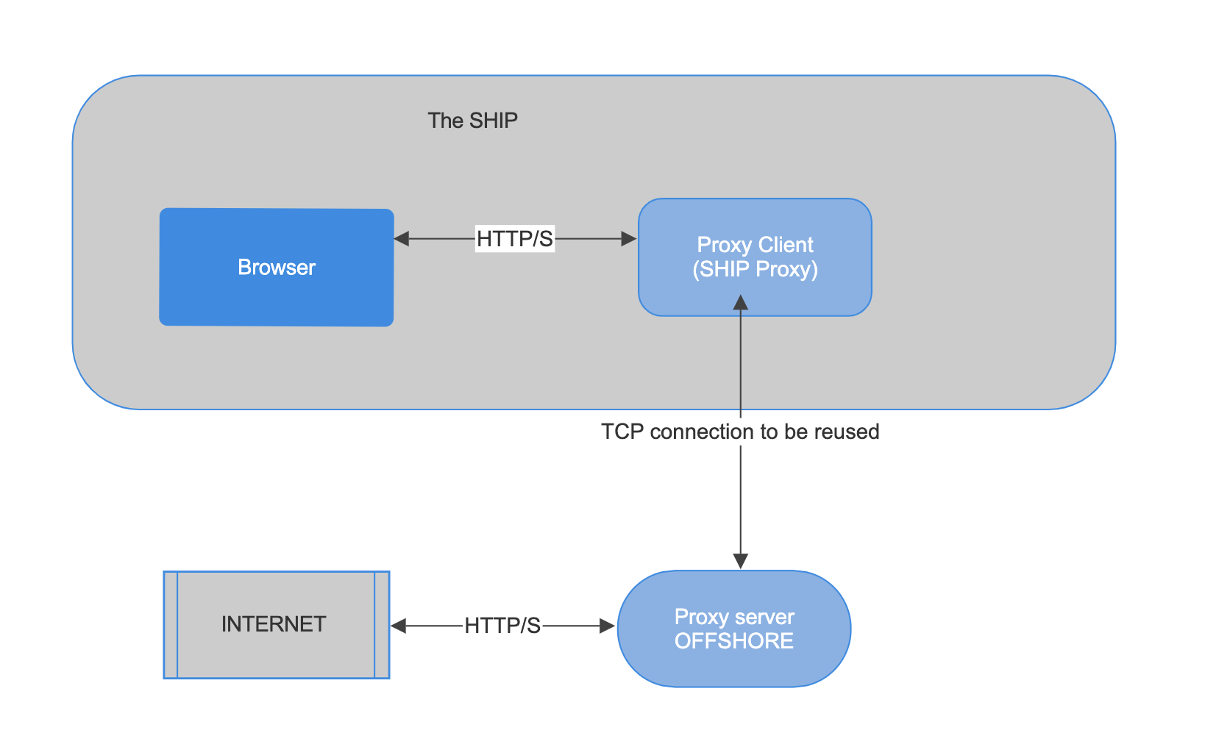

**Solution**

* Using a Persistent TCP Socket
* The Ship Proxy and Offshore Proxy communicate over a single persistent TCP connection.

How It Works:

Ship Proxy (Client)

* Acts as an HTTP proxy inside the ship.
* Establishes a single persistent TCP connection to the Offshore Proxy.
* Sends HTTP request URLs through this connection.
* Reads the response and sends it back to the browser.

Offshore Proxy (Server)

* Listens for TCP connections from the Ship Proxy.
* Forwards received requests to the Internet.
* Sends back the fetched response over the same TCP connection.
* Single Socket Connection Per Request
  + The Socket object is used synchronously inside the sendRequest() method.
  + The method waits for a response before returning.
  + If multiple requests arrive, each must wait for the previous one to finish before proceeding.
* Blocking I/O Model
  + BufferedReader.readLine() or reader.read(buffer, 0, buffer.length) blocks execution until data is received.
  + The request processing is not concurrent because each request executes one after another.

**Testing**

* Start the Proxy Server & Client (Spring Boot Application).
* Make Requests to the Proxy Client:
  + [http://localhost:8080/proxy?url=http://www.google.com](http://localhost:8080/proxy?url=http:/www.google.com)